Project Design Phase-II
Data Flow Diagram & User Stories
Date | 08 October 2026
Team ID | 9100Orbit
Project Name | Implement Client Script & UI Policy (Incident)
Maximum Marks | 4 Marks
Data Flow Diagram:
A Data Flow Diagram (DFD) is a visual representation of the information flows within a system. It shows how data enters and leaves the system, what changes the information, and where data is stored. The DFD below (Level 0) shows how an Incident record moves through the ServiceNow UI Policy and Client Script controls before it is saved.
DFD Level 0: Incident Client Script & UI Policy
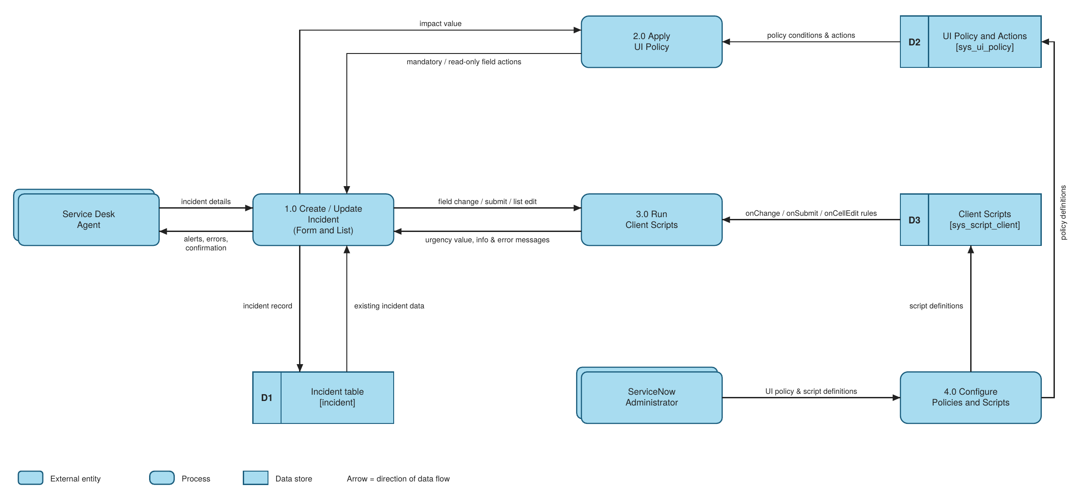
Flow
1. The Service Desk Agent enters incident details (caller, category, impact, short description) on the Incident form, or edits a field from the Incident list.
2. The form sends the Impact value to the UI Policy (2.0). It reads the policy conditions from the UI Policy store (D2). When Impact is 1 - High, Assignment group becomes mandatory and Urgency becomes read-only. These effects are reversed when the condition is no longer true.
3. The Client Scripts process (3.0) reads the script rules from the Client Script store (D3). onChange sets Urgency to High with an info message, onSubmit blocks saving a High-impact incident without Assigned To, and onCellEdit blocks State changes from the list.
4. Messages, errors or alerts return to the agent. When all rules pass, the incident record is saved in the Incident table (D1) and the agent receives confirmation.
5. The Administrator defines the UI Policy, policy actions and client scripts in the Configure process (4.0), which stores them in D2 and D3.
User Stories
User stories for the Implement Client Script & UI Policy (Incident) project.
User Type | Functional Requirement (Epic) | User Story Number | User Story / Task | Acceptance criteria | Priority | Release
Service Desk Agent | High Impact Control (UI Policy) | USN-1 | As an agent, I want Assignment group to become mandatory when Impact is High, so that high-impact incidents are always routed to a team. | Assignment group is mandatory when Impact = 1 - High | High | Sprint-1
Service Desk Agent | High Impact Control (UI Policy) | USN-2 | As an agent, I want Urgency to become read-only when Impact is High, so that priority stays consistent. | Urgency is visible but cannot be edited while Impact = High | High | Sprint-1
Service Desk Agent | High Impact Control (UI Policy) | USN-3 | As an agent, I want the restrictions removed when I lower the Impact, so that I can work normally on lower-impact incidents. | With Impact = 2 - Medium, Assignment group is optional and Urgency is editable (Reverse if false) | Medium | Sprint-1
Service Desk Agent | Auto-populate (onChange Client Script) | USN-4 | As an agent, I want Urgency to be set to High automatically when I choose High Impact, so that I do not enter it manually. | Urgency = 1 - High and the info message "Urgency set to High for High impact incident." appears | High | Sprint-2
Service Desk Agent | Save validation (onSubmit Client Script) | USN-5 | As an agent, I want to be stopped from saving a High-impact incident without Assigned To, so that no incident is left without an owner. | Save is blocked and the error "Assigned To is mandatory for High impact incidents." appears on the field | High | Sprint-2
Service Desk Agent | Save validation (onSubmit Client Script) | USN-6 | As an agent, I want to save the incident once Assigned To is filled, so that I can complete the record. | Incident saves successfully with no errors | High | Sprint-2
Service Desk Agent | List edit control (onCellEdit Client Script) | USN-7 | As an agent, I want State changes from the list view to be blocked, so that State is not changed by accident. | Alert "State cannot be updated using list editing. Please open the Incident." appears and State stays unchanged | Medium | Sprint-3
Service Desk Agent | List edit control (onCellEdit Client Script) | USN-8 | As an agent, I want to change State from the Incident form, so that I can still update the incident properly. | State change made on the form saves successfully | Medium | Sprint-3
Administrator | Configuration | USN-9 | As an administrator, I want to create the UI Policy "High Impact Control" with its actions, so that field behavior is controlled by Impact. | Active policy on the Incident table with condition Impact is 1 - High; actions for Assignment group and Urgency | High | Sprint-1
Administrator | Configuration | USN-10 | As an administrator, I want to create the onChange, onSubmit and onCellEdit client scripts on Incident, so that data rules are enforced on the form and list. | Three active client scripts saved on the Incident table and working in tests | High | Sprint-2
Service Desk Manager | Data quality and reporting | USN-11 | As a manager, I want complete and consistent incident data, so that reports and SLA tracking are accurate. | Every High-impact incident has an Assignment group and an Assigned To value | Medium | Sprint-3

